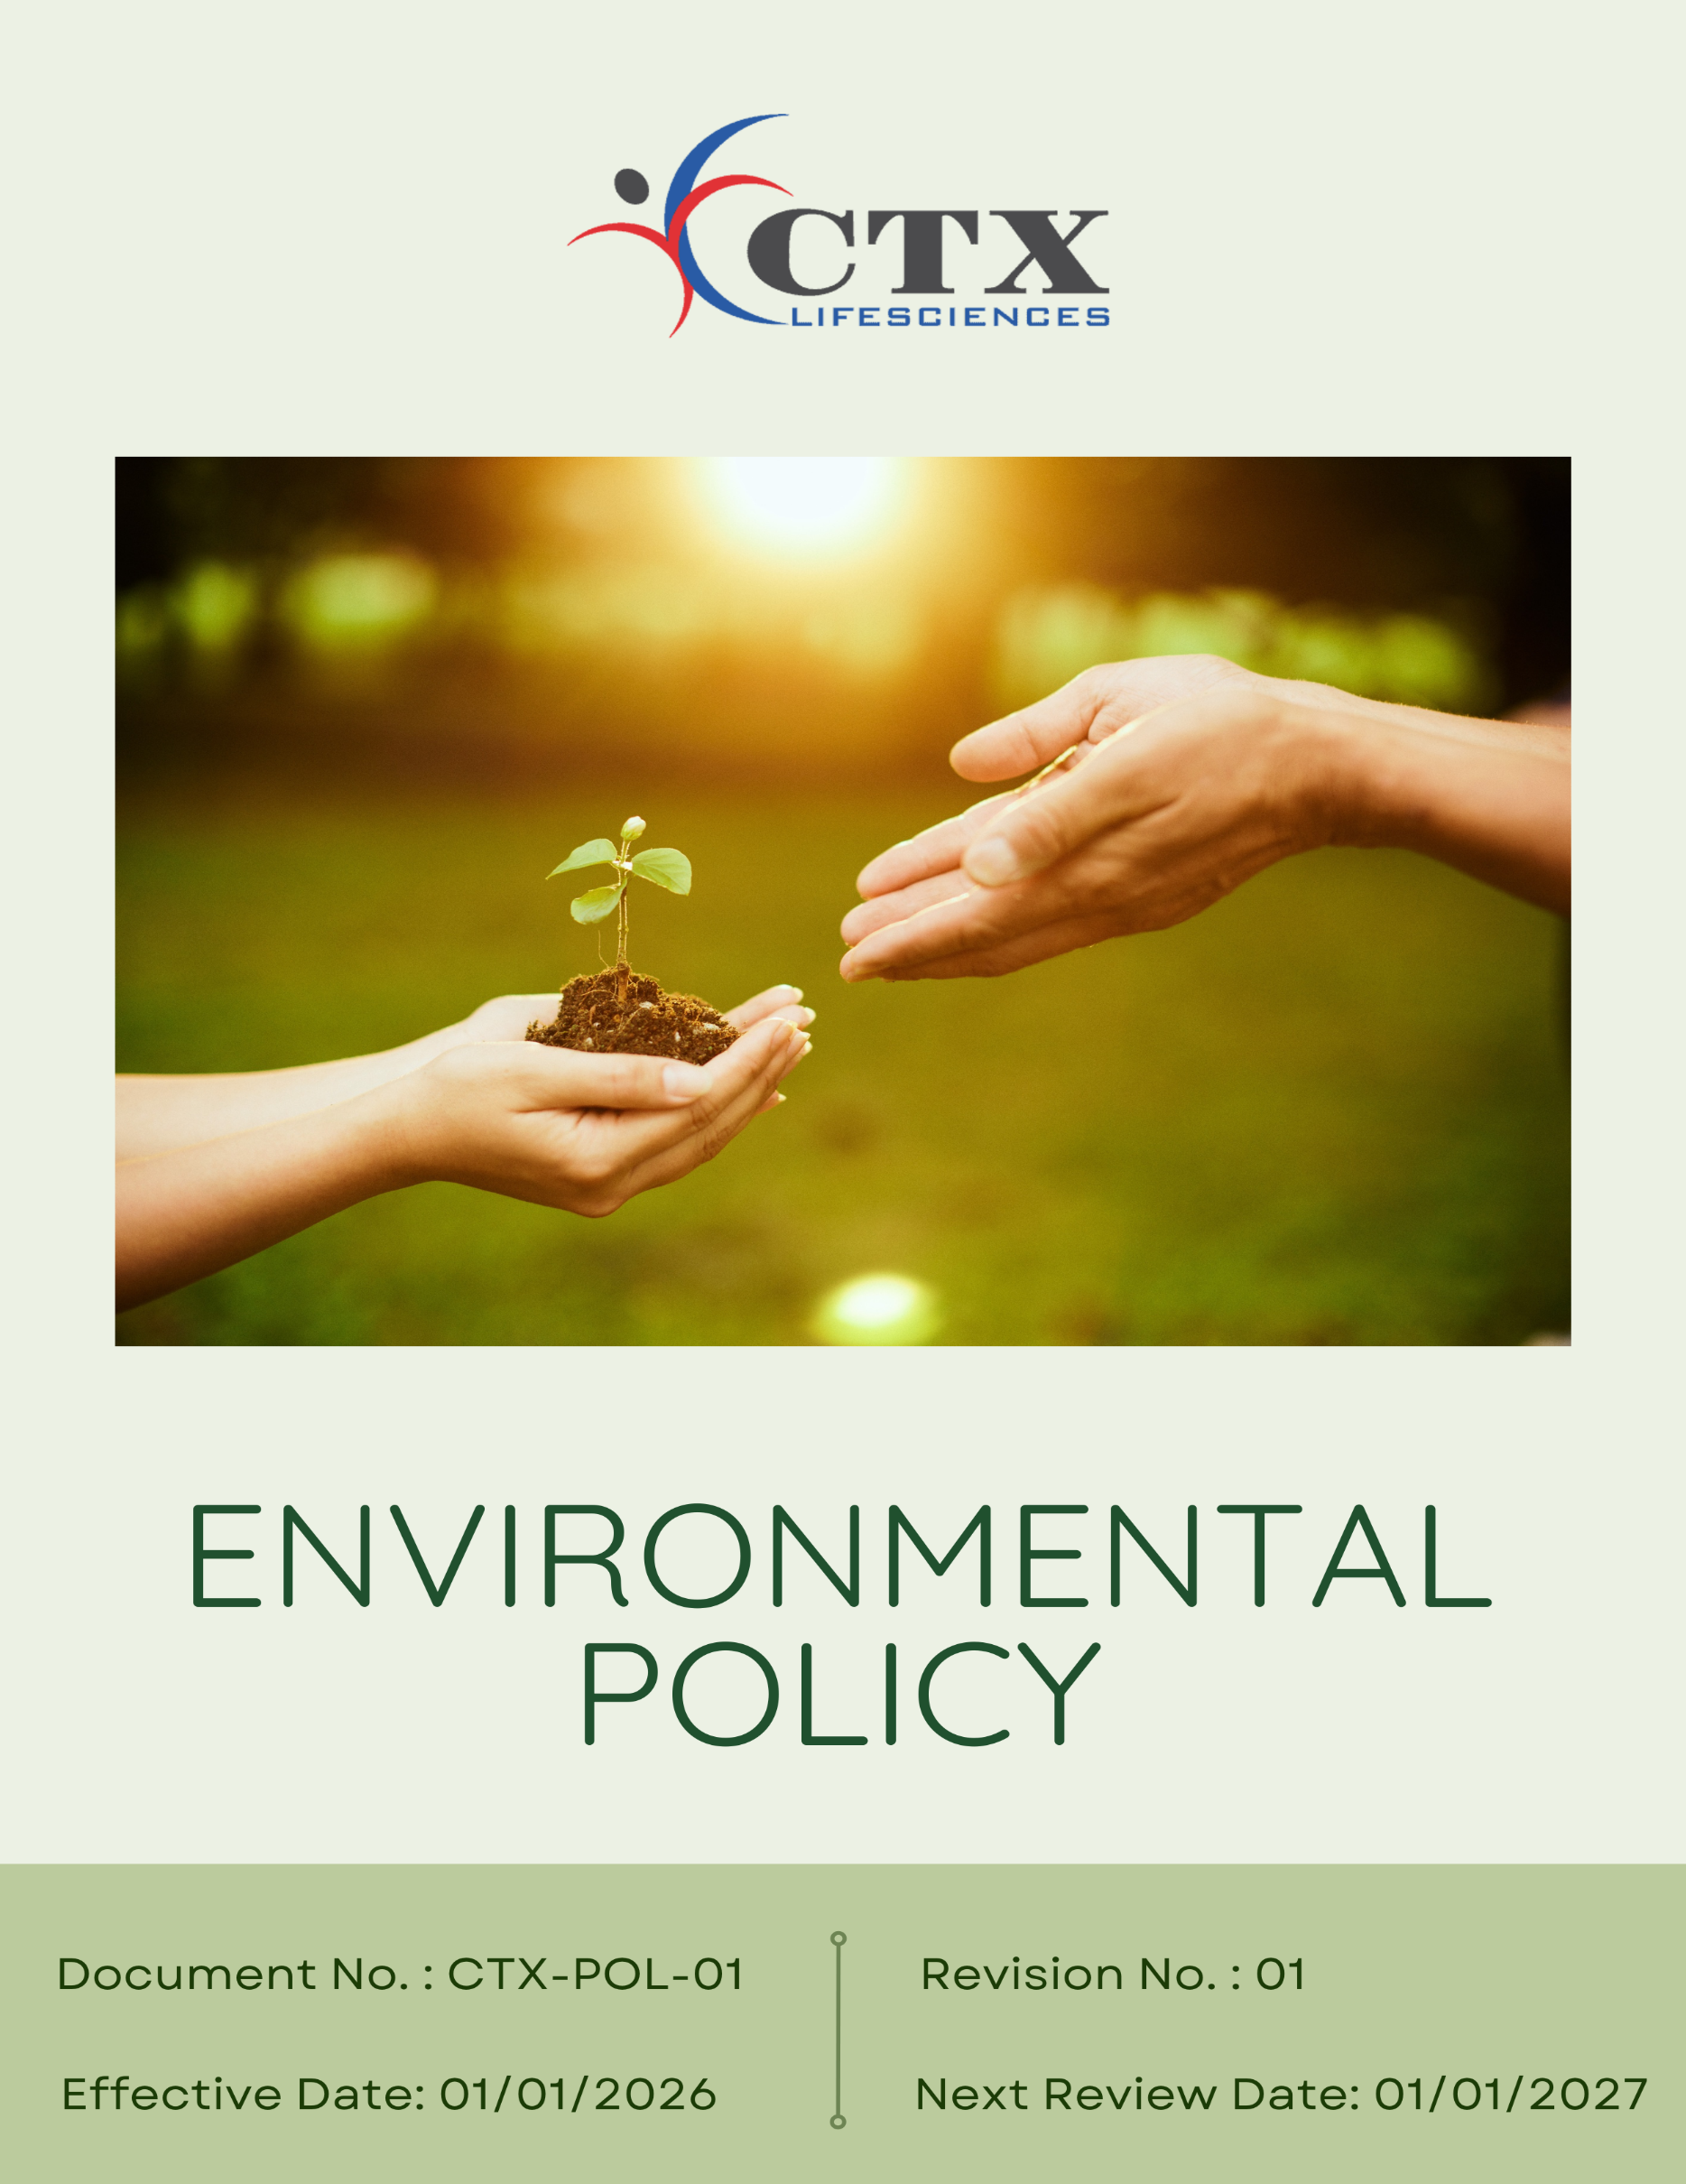
Contents

Preface 3
Policy Declaration 3
Scope 3
Key Focus Areas 4
Qualitative Objectives 5
Quantitative Targets 7
Alignment with the United Nations Sustainable Development Goals (SDGs) 9
Responsibilities 10
Monitoring, Reporting, and Transparency 10
Review Mechanism and Continuous Improvement 11
Employee Acknowledgment Form 12

Preface
CTX Lifesciences Pvt. Ltd. is committed to minimizing its environmental impact and supporting sustainable development through responsible environmental management and continuous improvement. As a vertically integrated manufacturer of Active Pharmaceutical Ingredients (APIs) and intermediates, the Company recognises that its operations interact with the environment and seeks to prevent pollution, conserve natural resources, and comply with all applicable environmental laws, regulations, and certifications. CTX operates with a robust environmental infrastructure, including effluent treatment and waste management facilities, and maintains ISO 14001:2015 and ISO 45001:2018 standards to promote environmental stewardship.
This Environmental Policy establishes the framework for CTX Lifesciences Pvt. Ltd.’s environmental objectives and targets, defines governance and accountability mechanisms, and outlines key initiatives to enhance environmental performance across all business operations. It guides employees, contractors, and stakeholders in integrating sustainability principles into daily activities, with the aim of advancing energy efficiency, resource conservation, waste reduction, and overall ecological responsibility.

Policy Declaration
CTX Lifesciences Pvt. Ltd. affirms its commitment to safeguarding the environment by preventing pollution, complying with all applicable environmental laws and regulations, and continually enhancing its environmental performance. The Company is dedicated to responsible management of natural resources, controlling emissions and effluents, minimizing waste, and integrating environmental considerations into all operational and business decisions. CTX Lifesciences fosters environmental awareness, accountability, and active engagement among employees, contractors, and stakeholders to promote sustainable practices across its operations.

Scope
This Environmental Policy applies to all operations of CTX Lifesciences Pvt. Ltd., including chemical manufacturing, storage, laboratory, and supporting functions conducted at its facility. It covers environmental aspects related to resource consumption, energy use, emissions, effluents, waste management, and chemical handling. The Policy applies to all employees, contractors, and service providers working on behalf of CTX Lifesciences, ensuring that sustainability and environmental responsibility are embedded throughout the organization’s operations.

Sr. No. | Company Name | Location | Address Details
1 | CTX Lifesciences Pvt. Ltd. | Head Office | Block No. 251–252, Sachin–Magdalla Road, Sachin GIDC, Surat – 394230, Gujarat, India
2 |  | Factory | Block Nos. 251/B, 252/B, 253, 254, 255, 256, 258/B, 276, 277, 278/P, 279, 280, 281, 282, 283/P, 284/P, Sachin GIDC, Near Gabheni Chokdi, Sachin, Surat – 394230, Gujarat, India

Key Focus Areas
- Energy Consumption & GHG Emissions – Improve energy efficiency and reduce greenhouse gas emissions.
- Air Emissions Control – Control air emissions and comply with regulatory standards.
- Raw Materials Management – Optimize raw material use and reduce process losses.
- Waste Management – Minimize waste generation and promote reuse and recycling.
- Water Stewardship – Reduce water use and ensure effective wastewater treatment.
- Biodiversity Protection – Prevent contamination and limit impacts on ecosystems.
- Responsible Product Use – Apply life-cycle thinking to reduce environmental impact.
- Product End-of-Life Management – Support safe disposal, recovery, and recycling.
- Customer Health & Safety – Ensure safe, compliant products and responsible use.
- Employee Awareness & Engagement – Build awareness through training and participation.
- Environmental Services, Partnerships & Advocacy – Collaborate with stakeholders to promote sustainability.

Qualitative Objectives
- Energy consumption & GHG Emissions
- Improve energy efficiency by installing energy-efficient motors, pumps, variable frequency drives (VFDs), and LED lighting across operations.
- Optimize boilers, chillers, utilities, and HVAC systems through preventive maintenance and operational controls.
- Explore cleaner fuel alternatives to reduce greenhouse gas emissions.

- Air Emissions Control
- Maintain and operate scrubbers, filters, and local exhaust ventilation systems to control process emissions.
- Conduct regular stack and ambient air monitoring to ensure compliance with applicable air quality norms.
- Reduce fugitive emissions through proper chemical storage, closed handling systems, and routine equipment maintenance

- Raw Materials Management
- Optimize raw material consumption through batch optimization, yield improvement, and process standardization.
- Minimize material losses by strengthening inventory management, storage conditions, and handling procedures.
- Encourage efficient chemical dosing and substitution of high-loss materials where feasible.

- Waste Management
- Maintain implementation of waste segregation at source for hazardous, non-hazardous, recyclable, and recyclable packaging waste.
- Recycle solvents, residues, and packaging materials through in-house recovery systems and authorized recyclers.
- Ensure safe storage, documentation, and disposal of hazardous waste through approved waste management vendors.
- Water Stewardship
- Reduce freshwater usage through process optimization, leak prevention, and water-efficient practices.
- Operate and optimize existing effluent treatment and water recycling systems to maximize reuse.
- Monitor effluent quality regularly to ensure compliance with discharge standards.

- Biodiversity Protection
- Develop green belts around manufacturing sites with native tree plantations.
- Collaborate with local environmental organizations to support habitat conservation.

- Responsible Product Use
- Provide customers with clear guidance on safe handling, storage, and efficient product usage.
- Support customers with technical advice to minimize waste, emissions, and resource use during application.
- Review customer feedback to improve product performance and environmental compatibility.

- Product End-of-life Management
- Enable safe disposal and recovery of expired or off-spec products through authorized facilities.
- Promote reuse or recycling of drums, containers, and packaging materials where feasible.
- Maintain records of product disposal and recovery to support circular economy practices.

- Customer Health and Safety
- Ensure all products comply with chemical safety regulations before market release.
- Maintain and update labeling, hazard communication, and SDS for regulatory compliance.
- Monitor and review product safety performance to identify improvements in handling and usage.
- Conduct targeted training for customers on safe handling practices and emergency response.

- Employee Awareness & Engagement
- Conduct role-based environmental training for employees covering waste management, emissions control, and spill prevention.
- Integrate environmental responsibilities into SOPs and daily work practices to reinforce sustainable behavior.
- Encourage employee participation in environmental improvement and compliance initiatives.

- Environmental Services, Partnership & Advocacy
- Conduct employee training on environmental responsibility and sustainable practices.
- Engage suppliers and contractors on environmental compliance and responsible material sourcing.
- Support local environmental programs such as plantation drives and awareness initiatives.
- Track environmental performance and promote continual improvement through internal reviews and reporting.

Quantitative Targets
The baseline year for all quantitative environmental targets at CTX Lifesciences Pvt. Ltd. is established as FY 2022–23, serving as the reference point for measuring progress across the Company’s key environmental focus areas. This baseline enables a structured and consistent evaluation of improvements in resource efficiency, emissions reduction, and overall environmental performance.

- Energy consumption & GHG Emissions
- Achieve 100% LED lighting coverage across production, utilities, and administrative areas by FY 2029–30 and maintain thereafter.
- Increase the share of renewable energy to 20% of total energy consumption by FY 2029–30.
- Reduce total energy consumption by 25% compared to the FY 2022–23 baseline by FY 2029–30.
- Achieve a total 30% reduction in Scope 1 and Scope 2 GHG emissions by FY 2029–30 through energy efficiency and cleaner energy adoption.

- Air Emissions Control
- Upgrade or retrofit 50% of existing air pollution control systems with improved filtration media, automated monitoring, or efficiency-enhancing components by FY 2029–30 to further reduce particulate and gaseous emissions.
- Achieve a 30% reduction in air pollutant emissions compared to FY 2022–23 by FY 2029–30 through effective operation and maintenance of scrubbers, filters, and ventilation systems.
- Reduce diesel vehicle use by 15% by FY 2029-30 through route optimization and improved scheduling.

- Raw materials Management
- Reduce process-related material losses by 5% by FY 2029–30 through improved handling, storage, and process controls.
- Increase the use of recycled or alternative raw materials by 10% by FY 2029-30 where technically feasible to support resource efficiency and circularity.

- Waste Management
- Divert 90% of waste from landfill by FY 2029–30 through segregation, reuse, recycling, and recovery.
- Implement waste tracking and reporting for 100% waste streams (hazardous and non-hazardous) by FY 2029-30.
- Reduce total waste generation by 10% till FY 2029–30.

- Water Stewardship
- Reduce total freshwater consumption by 30% till FY 2029–30 through water-efficient practices and rainwater harvesting where applicable.
- Reuse 40% of treated wastewater within operations by FY 2029–30.
- Maintain 100% compliance with effluent discharge standards regularly.

- Biodiversity Protection
- Plant and maintain 500 native trees around the company facilities by FY 2029–30.
- Implement 2 habitat restoration projects by FY 2029-30 in collaboration with community and environmental partners to prevent contamination and ecological degradation.
- Maintain ≥90% survival rate for all plantation and green-belt development activities annually.

- Responsible Product Use
- Conduct environmental performance reviews for 30% of products by FY 2029–30 to identify impact-reduction opportunities.
- Achieve a 10% reduction in the lifecycle environmental footprint of key specialty chemical products by FY 2029-30 through formulation optimization, energy efficiency improvements in application, and enhanced performance characteristics.
- Ensure 100% of products are supplied with clear usage instructions and environmental handling guidance.

- Product End-of-life Management
- Increase the use of recycled and repurposed materials to 30% in product packaging, intermediates packaging and bulk containers by FY 2029-30 to promote circular resource use.
- Ensure provision for 100% safe disposal of expired or off-spec products through authorized waste management facilities till FY 2029-30.
- Provide end-of-life handling and disposal guidance for 100% applicable products by FY 2029–30.

- Customer Health and Safety
- Conduct 2 customer safety awareness or communication initiative till FY 2029-30
- Ensure 100% of products have accurate labeling, hazard communication, and up-to-date Safety Data Sheets (SDS).
- Maintain zero product recalls or regulatory actions related to customer health and safety.

- Employee Awareness & Engagement
- Conduct three employee engagement initiatives related to sustainability or environmental performance by FY 2029–30.
- Ensure 100% role-specific environmental training for employees in production, utilities, and EHS functions.
- Maintain minimum 90% employee participation in environmental or sustainability initiatives till FY 2029–30.

- Environmental Services, Partnerships & Advocacy
- Train 80% of suppliers on sustainability practices and environmental management by FY 2029–30.
- Participate in 3 environmental or community initiative in collaboration with external stakeholders till FY 2029-30

Alignment with the United Nations Sustainable Development Goals (SDGs)
The sustainability objectives and performance targets align with the following Sustainable Development Goals (SDGs):
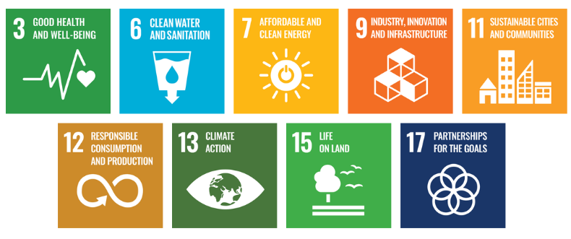

Responsibilities
- EHS Manager: Oversees implementation and monitoring of the Environmental Policy, ensures regulatory compliance, leads training, and coordinates environmental reporting.
- Department Heads & Operations Teams: Integrate environmental goals into departmental functions, collaborate with the EHS Manager, and implement initiatives such as waste reduction, water conservation, and energy efficiency.
- Employees: Follow environmental guidelines, participate in sustainability initiatives, and adopt best practices to support CTX Lifesciences sustainability objectives.
- External Stakeholders: Support sustainability efforts through partnerships and compliance with environmental standards.

Monitoring, Reporting, and Transparency
CTX Lifesciences Pvt. Ltd. continuously tracks its environmental performance across key areas, including energy consumption, greenhouse gas emissions, water management, waste reduction, and product safety. Key Performance Indicators (KPIs) are established for each area and monitored through internal systems to assess progress against defined sustainability targets. Performance results are reviewed quarterly and consolidated for senior management to support informed decision-making. Annual evaluations assess achievements, identify gaps, and recommend corrective actions, with relevant outcomes communicated to stakeholders to ensure transparency and accountability. All monitoring and reporting adhere to applicable regulations and industry best practices to ensure reliability and accuracy.

Review Mechanism and Continuous Improvement
This Environmental Policy will be reviewed annually by the EHS Manager and updated as required to reflect changes in regulatory requirements, industry standards, and internal environmental objectives. Updates will be communicated to all employees, contractors, and relevant stakeholders to ensure consistent application. Revisions aim to strengthen environmental commitments, enhance operational sustainability, and drive continuous improvement across all CTX operations.

Effective Date | : 01.01.2026
Next Review Date | : 01.01.2027
Revision No. | : 01

Approved By:

Employee Acknowledgment Form
I hereby acknowledge that I have read and understood the Environmental Policy of CTX Lifesciences Pvt. Ltd. I am aware of the company’s commitment to responsible environmental practices, including energy efficiency, resource conservation, waste reduction, pollution control, and full compliance with all applicable environmental laws and standards. I understand that environmental sustainability is a shared responsibility, and I pledge to follow sustainable practices in my daily work, minimizing waste, using resources efficiently, and adhering to the company’s environmental protocols. I will actively support CTX Lifesciences’ efforts to achieve its sustainability objectives and contribute to creating a cleaner, safer, and more responsible workplace.
By signing this document, I confirm my commitment to the environmental values of CTX Lifesciences Pvt. Ltd. and agree to participate in training programs, awareness initiatives, and continuous improvement activities as required.

Employee Name | : _________________________
Employee ID | : _________________________
Department | : _________________________
Signature | : _________________________

